**Democratizing Interior Design**

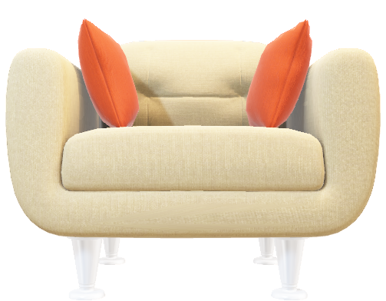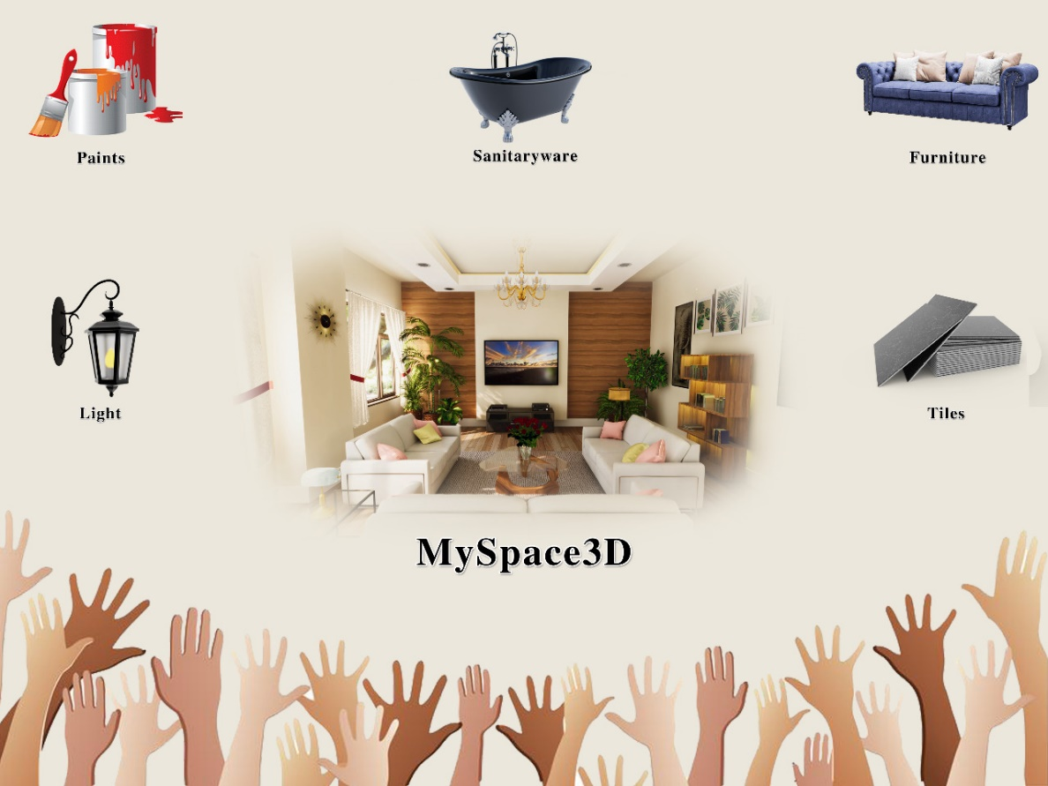

As Mark Hampton quotes, "Real comfort, visual and physical, is vital to every room." Giving that opportunity and space of individuality and design to everyone? That’s the vision at VisCommerce. The market is growing sharply with the global real estate sector gradually becoming a huge part of the global economy.

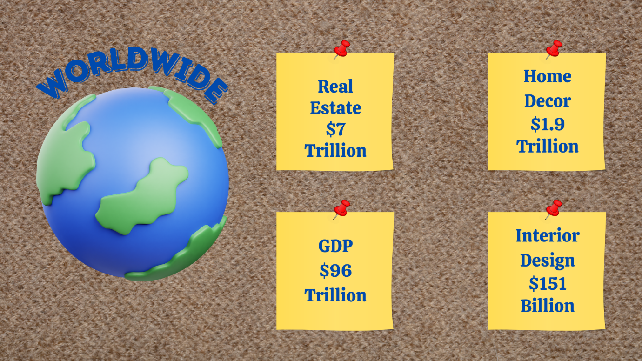

The market forecast for the real estate business is positive, the Indian real estate sector will reach a market size of $1 trillion by 2030 and account for 13% of India's GDP by 2025. While in the U.S. market, real estate construction contributed $1.15 trillion to the nation's economic output in 2018, accounting for 6.2% of the expected GDP. The US real estate market has also seen a boom at $3.8 trillion in 2022. With the boom in real estate all over the world, the demand for good-quality interior design has also increased.



Interior design is individualistic, subjective, and open to having a different purpose for everyone. It is something that might represent someone’s personality or simply might represent the purpose and identity of a place. The US interior design industry market was worth [$41 billion in 2020](https://whydoeseverythingsuck.net/blog/interior-design-statistics/#%2440.7%20billion%20in%202020).

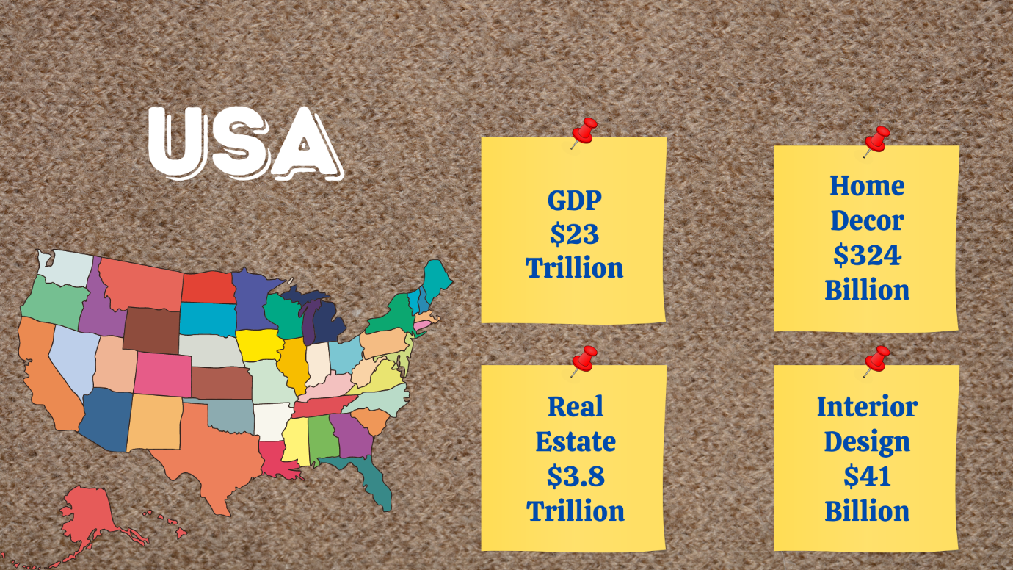

Even with so much investment, an ideal combination of the right kind of light, paints, décor, and materials that match your ideas are hard to execute. Consider being able to plan everything in detail and build a 3D prototype before actually implementing the project, from the color of the walls to the shade of the lamp. This will reduce the risk of failure and allow you to experiment with as many combinations as you like. The introduction of the try-and-buy concept in this sector will mean highly beneficial for both the buyer and the seller. Conglomerates like AutoDesk, and SolidWorks are already ahead when it comes to executing projects through prototypes.

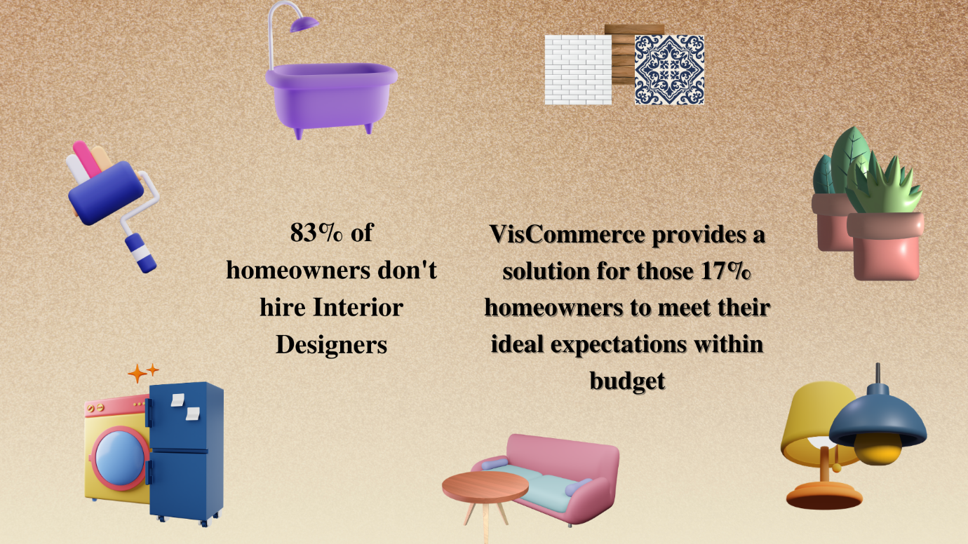

Simulation has been greatly involved in civil, electrical, and mechanical engineering for creating project prototypes to minimize errors in execution. Inspired by the same, we’ve integrated simulation with home decor and made quality interior design affordable for the remaining 83% of households who hesitate in hiring interior design due to high financial risk by uniting the try-and-buy strategy with simulation and 3D visualization. For the sellers, it will create new revenue streams with strategies such as “Shop-The-Look”.

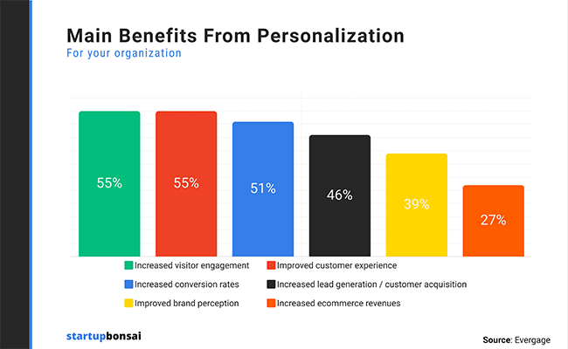

Remodeling the house, designing an office, building a hotel? Customers are majorly looking for personalization. 80% of consumers are more likely to buy from a company that provides a tailored experience and 70% of consumers say that how well a company understands their individual needs impacts their loyalty.

The home decor market can enhance not only their customer experience but also give a boom to their profits and brand loyalty!

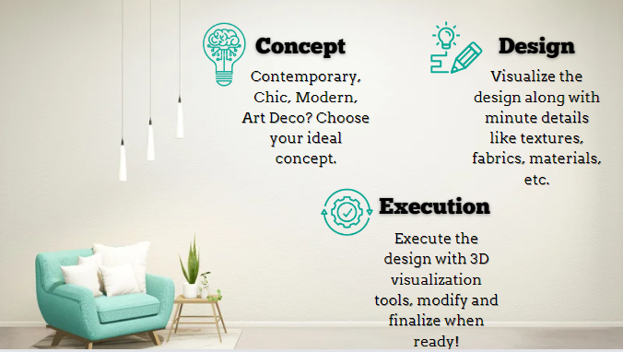

Almost 78% of consumers now expect brands to be aware of their expectations and work to achieve them. This is crucial in the buying process since the competition is always eager to offer the buyer other options. According to a recent poll of the furniture sector, 74% of consumers believe that buying in a 3D virtual store is a more thrilling experience than shopping in 2D photographs, and 75% prefer shopping in 3D to shopping in 2D photos.

Simulation benefits are less financial risk, gaining insights for improvement, assessing random events, and encouraging in-depth thinking.

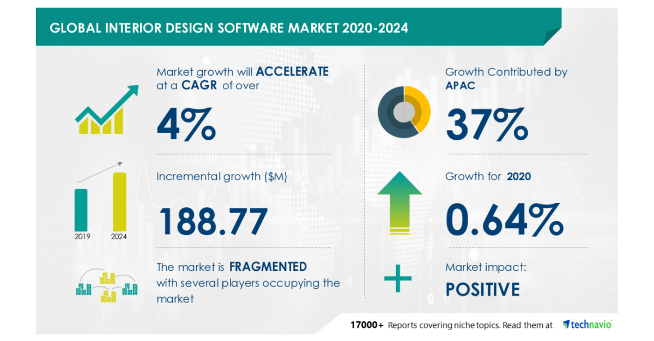

According to Grandview Research, augmented shopping is expected to expand at a rate of roughly 50% per year through 2027. Digital engagements with products that have 3D or AR content have a 94 percent greater conversion rate, according to Shopify. The adoption of 3D and AR-infused e-commerce has nearly doubled the revenues of top furniture companies like Amazon, Wayfair, Ashley Furniture, and others throughout the world. DFS, the UK's largest furniture retailer, sees a 22x return on investment in Augmented Reality, with up to 112 percent conversion lift and 106 percent revenue per visit.

Being ahead of the technological curve improves the customer experience and provides companies with a competitive edge in the market.

**Introducing Store3D and MySpace3D**

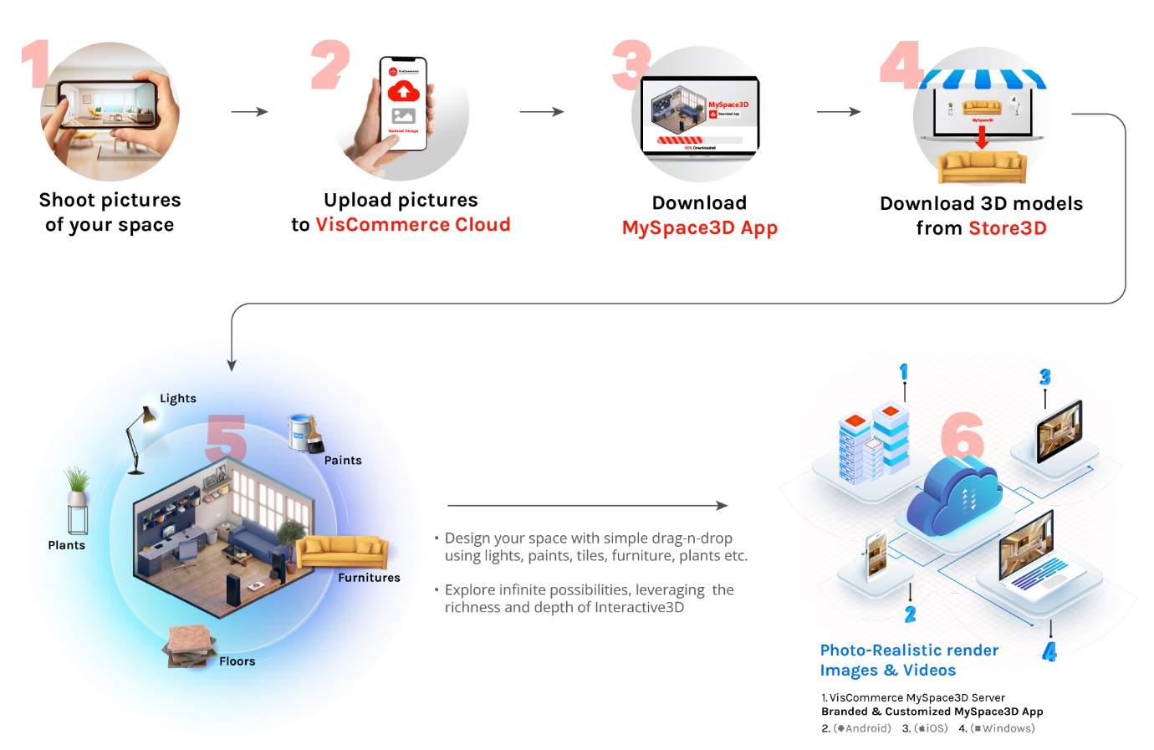

Imagine how much simpler it would be to choose a lamp, a couch, or a table if you could see how it looks in your own home. You would be able to design the space from the ground up and be able to change every single element of the space. The process includes the texture of the furniture and walls as well as the paint and solid materials utilised to produce the final appearance. Viscommerce's USP is its capacity to control lighting from its spectrum of brightness to turn it on or off.

Here, the idea of "try before you buy" is utilized, with the chance for user personalization. The process is just as simple for those who are less tech-savvy as it is for those who are. Taking detailed images of the room to be designed, including the walls, floors, and ceilings, is all that is required to get started. The photos are then uploaded to the VisCommerce cloud, from where Myspace3D comes into play.   The uploaded photos of the space are accurately replicated as 3D models using my space3D in terms of shape, size, and material, without having to do anything manually.

This virtual 3D replica of the area can be customized to suit specific user needs. Users can drag and drop digital twins of many commercially available home décor items from Store3D into their 3D model. Users can alter their space however they wish until striking the correct combinations, using everything from multiple sorts of tiles to fabric textures. The catalog features a variety of furniture, lighting, paint, tiles, plants, and sanitary items. The materials used to create the home décor items are incredibly realistic, down to the textures. Users can render and verify at any moment while experimenting with the space in several conditions, such as day, evening, and night, to view the designed room in real time. It excessively reduces the time and effort required by the customer by giving the option to find almost all items and combinations at one place. It also is as beneficial to the vendors by encouraging bulk buying.



One of the major issues in the tech world which creates a barrier against innovation is data privacy. VisCommerce addresses this issue efficiently with its Content Management System ensuring complete privacy of users’ uploaded content which then goes through 3D reconstruction. The exact measurements are extracted using AI to create scale and material-accurate 3D models of the space, which are then open to be modified in any way the client wants.

Before introducing 3D and AR-infused e-commerce, it's important to comprehend that it draws in new customers, enables a creative and innovative visual display of products, and moves customers through your customer journey map, culminating in the purchase and offering a strong ROI.

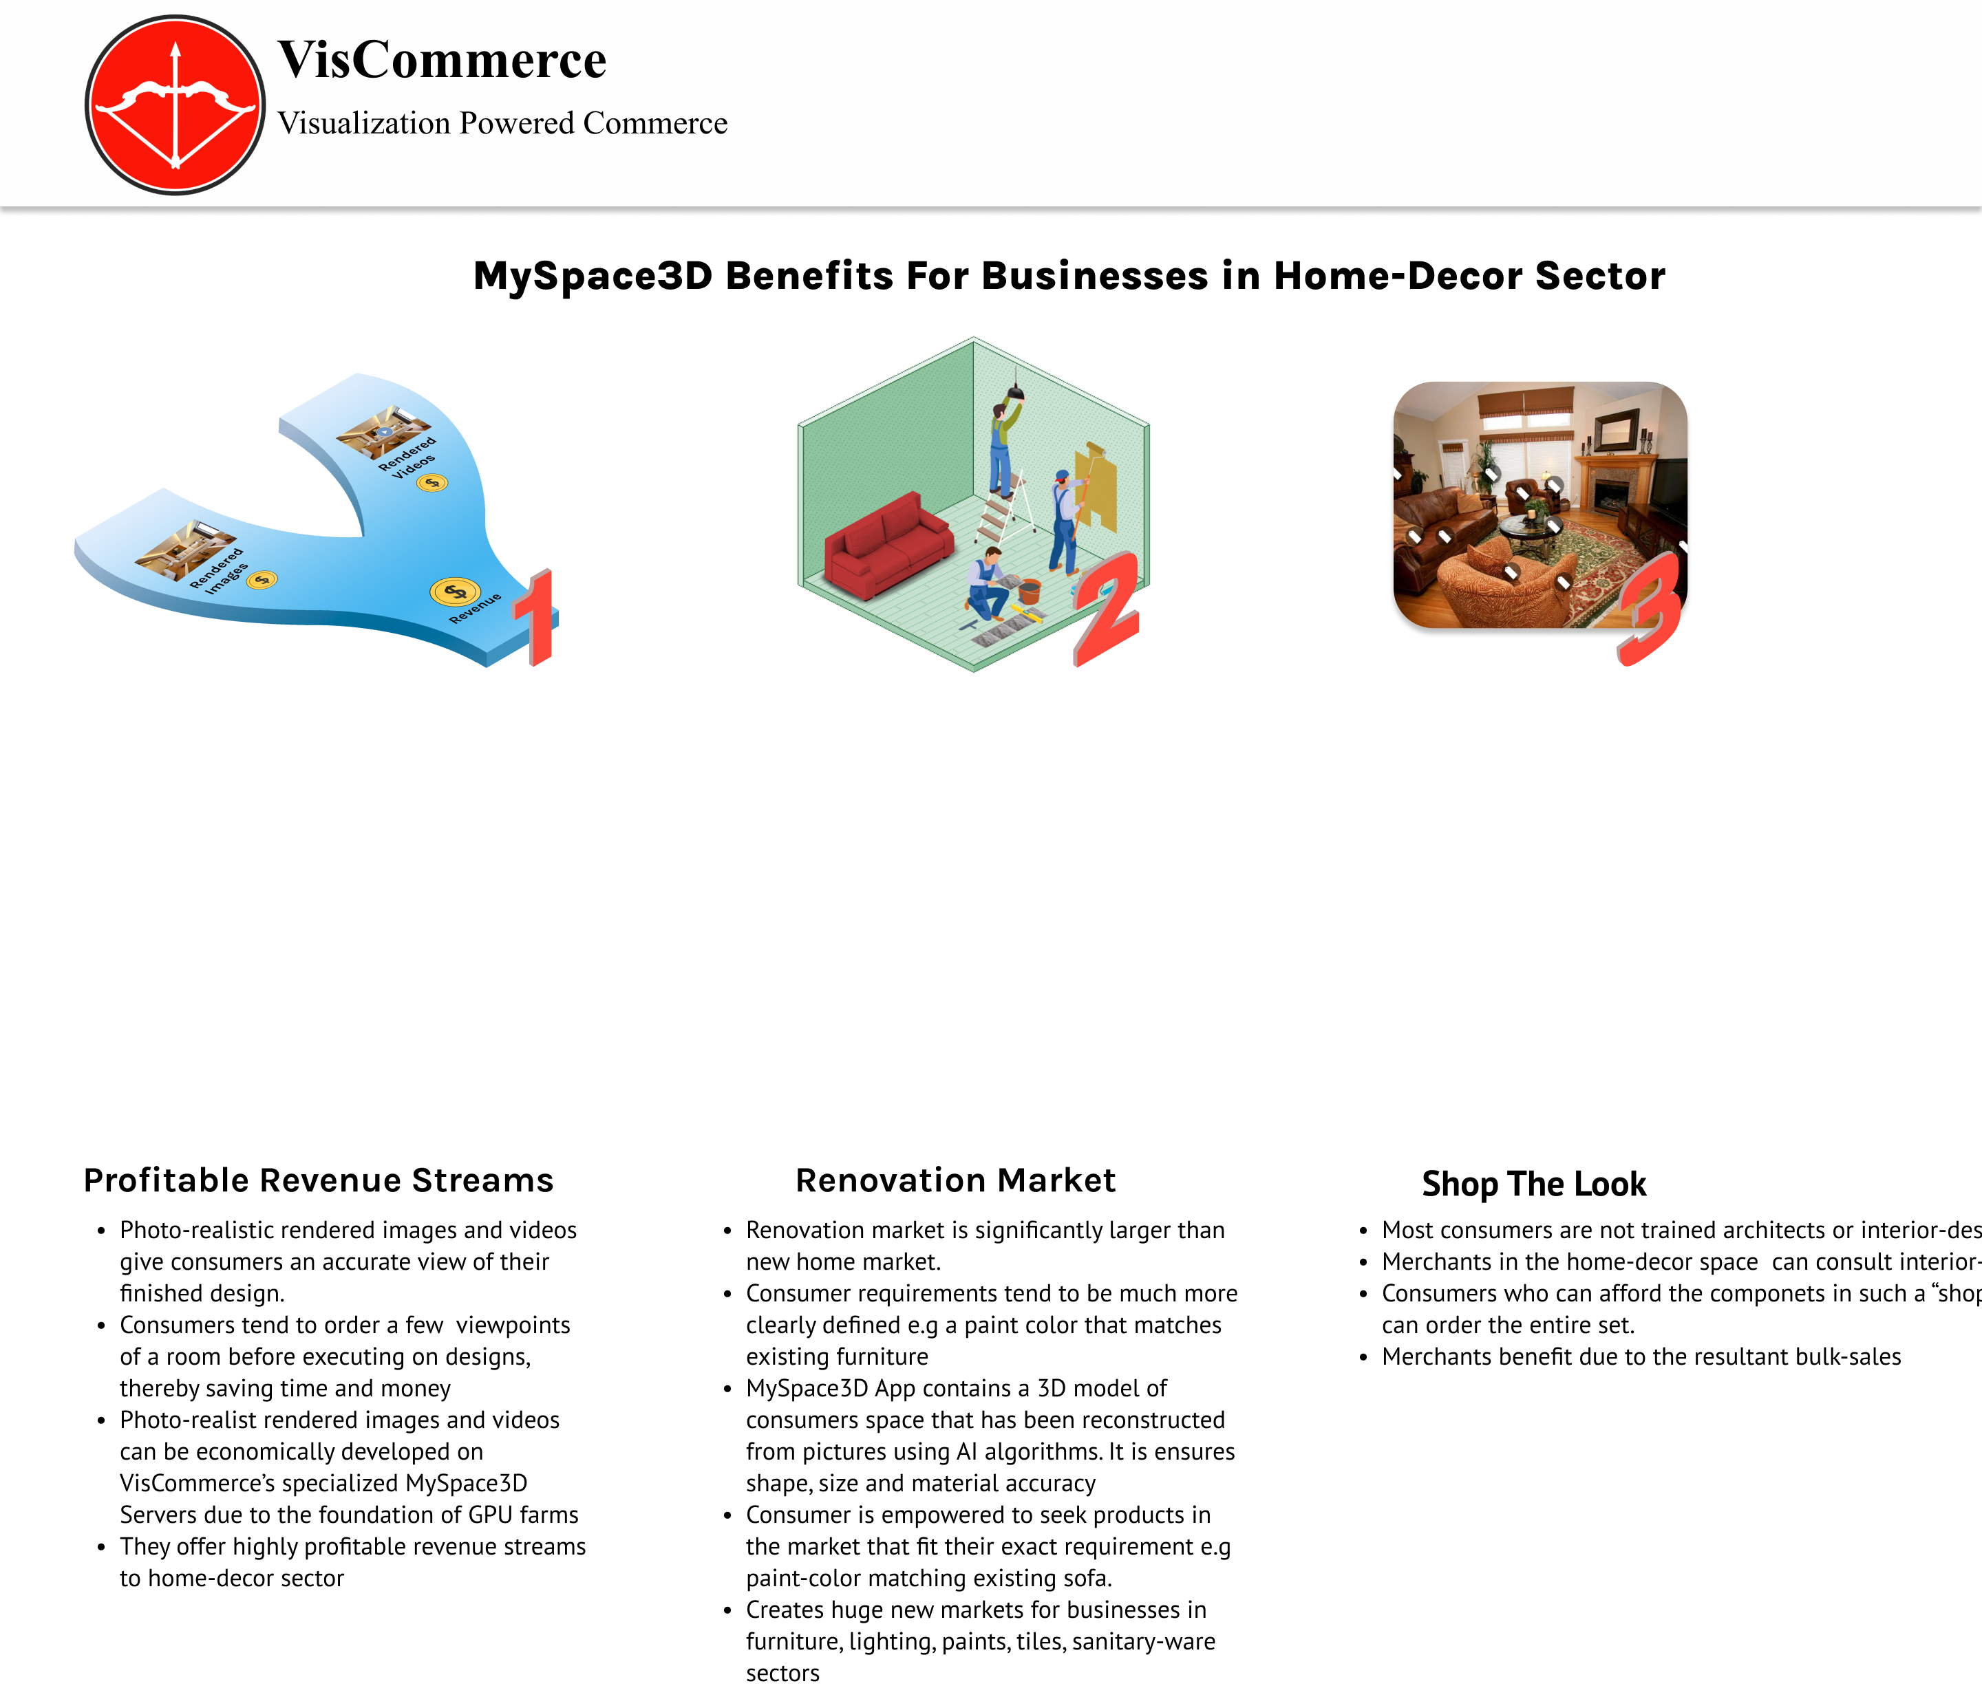

While giving way to bulk sales, the app encourages customers to design a complete room to promote to purchase of an entire design in one go. Every client will be inspired to customize according to their requirements, successfully optimizing their value of money, while the sellers will see enhanced customer retention.



**White-label our products**

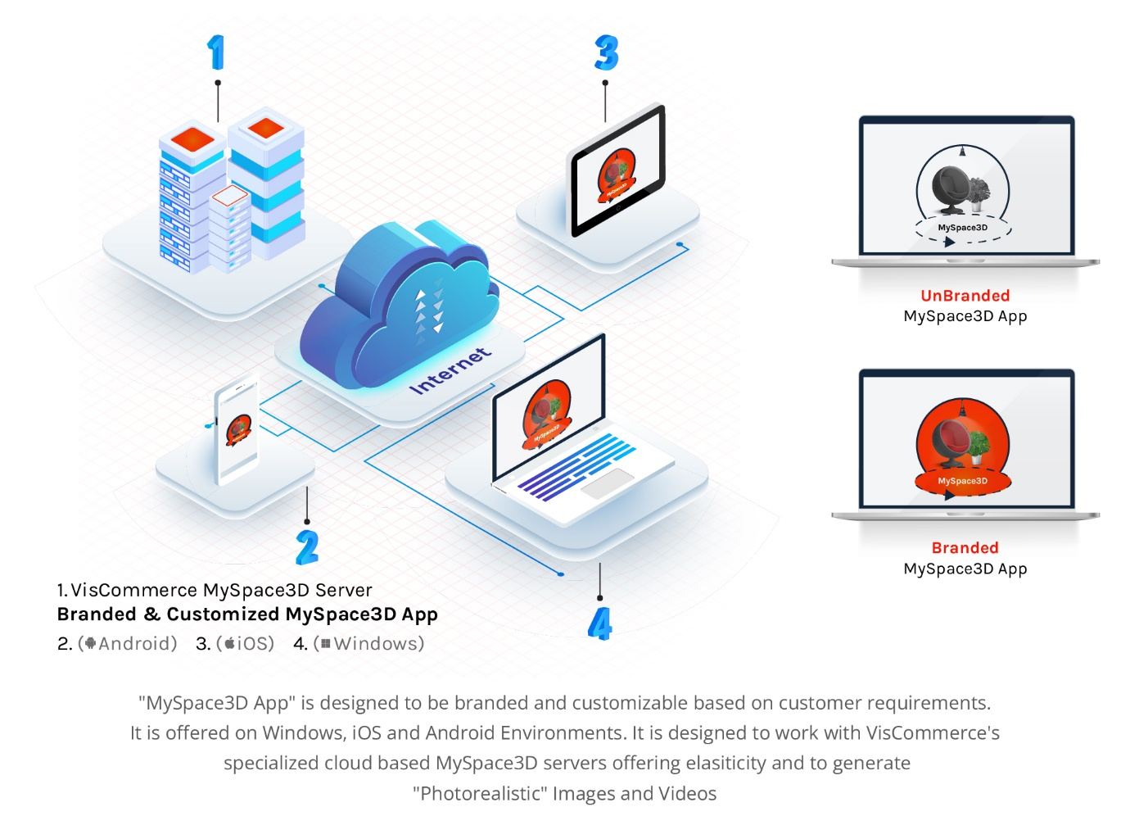

All businesses are built on tackling problems and coming up with workable solutions. In the 3D and AR market, there are several significant players active in B2B to address such issues and deliver solutions to businesses. This is referred to as white labeling. For example, large merchants and organizations such as AshleyFurniture, Lowe's Home Improvement, and others have made their services available to Marxentlabs. They have seen up to a 2x boost in revenue, exceptional customer satisfaction, and increased loyalty as a result of implementing cutting-edge technologies. This technology has changed how we think about interior design as homeowners and business owners.

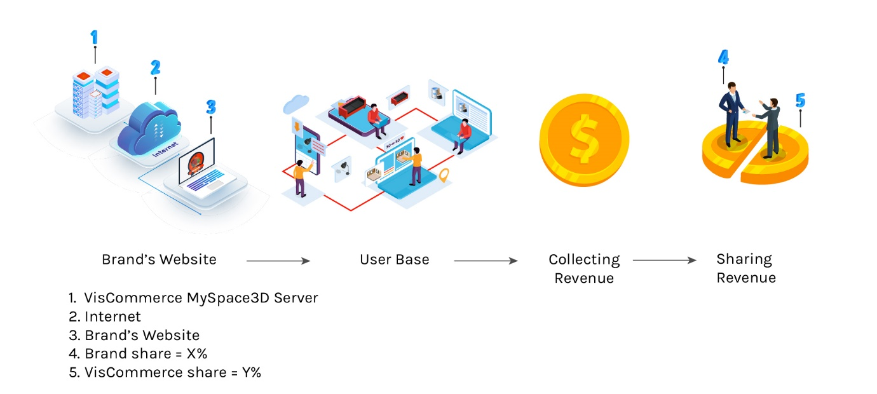

The white-label strategy is a win-win situation for both us and the sellers. The brand’s website can be enhanced enough to not only get customers but also to retain them and win their loyalty. The loyal customer base will enable high revenue generation, which will be divided between VisCommerce and the merchant according to pre-decided, mutually agreed terms.

**Conclusion**

Patent pending solution by VisCommerce offers unprecedented power to folks interested in Interior Design. This could range from homeowners to commercial space designers like a Dentist’s Office etc. This innovation from VisCommerce leverages many leading technologies such as 3D, AI, Blockchain, Crypto, and Web-Technologies. It offers new revenue streams, new markets, and bulk sales for vendors in the furniture, paints, tiles, lighting, and sanitaryware sectors.

Recognizing, adopting, and keeping up with the ever-changing corporate settings has been the key to success and popularity. With Myspace3D, Viscommerce has created a sustainable loop of revenue generation along with customer experience benefits for decor companies.